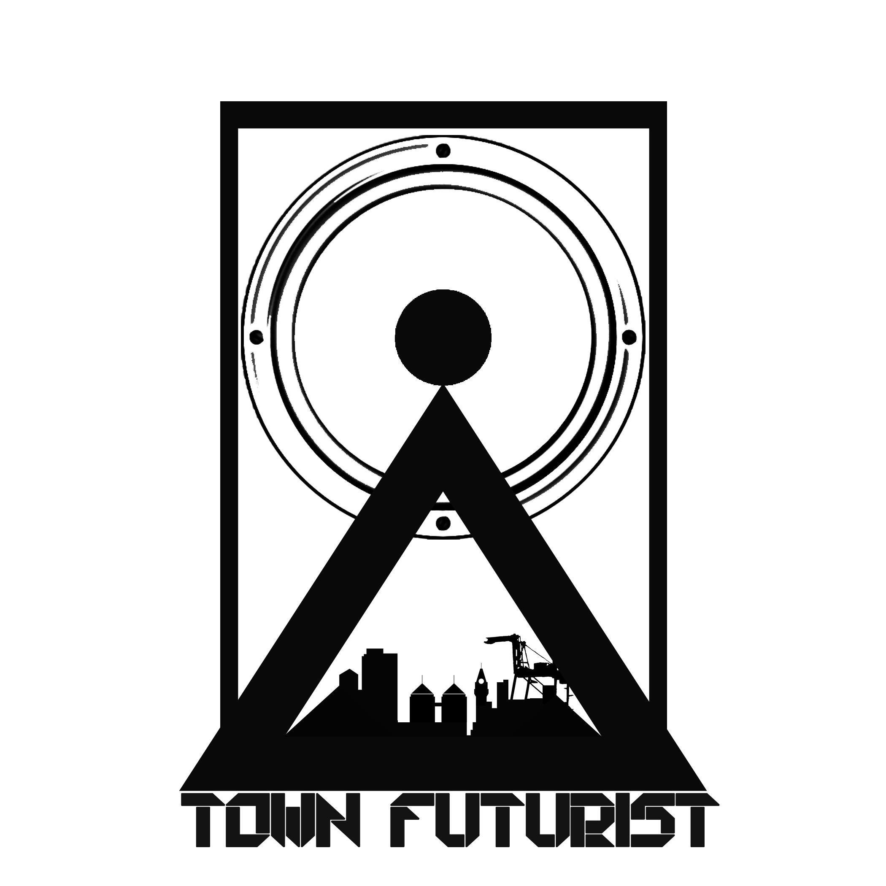 TownFuturist Media Price List

Intimate Session

An Intimate Session is a live recording of you performing 1 song of your choice at the TownFuturist Studio or a Location of your choice.
Note: Locations can reflect the price of the session. Local Northern California location only please.

These sessions are shot with 2 Canon cameras and 2 GoPro. The takes will be edited together out of a combination of five takes of your song. Your performance is recorded four times and then edited with the best shots and audio take.

The Live recording is a combination of however many tracks you need to perform your song. If you need 4 inputs then there will be 4 tracks to mix, etc. We have the ability to track 16 separate inputs and mix them together for the final master, which we sync to the video later.

The shoot consists of 2 cameramen and an on director/engineer. We shoot/ book 3hours blocks for the day of the shoot. The first half hour will be set-up and lighting. The last two hours will be shooting your song until you’re happy with the performance.

Budget:
Intimate Session: $550

Intimate Sessions are booked Sundays from 3-6pm.

Contact:
Korise Jubert
TownFuturist@Gmail.com
510-269-0433
Follow @TownFuturist

