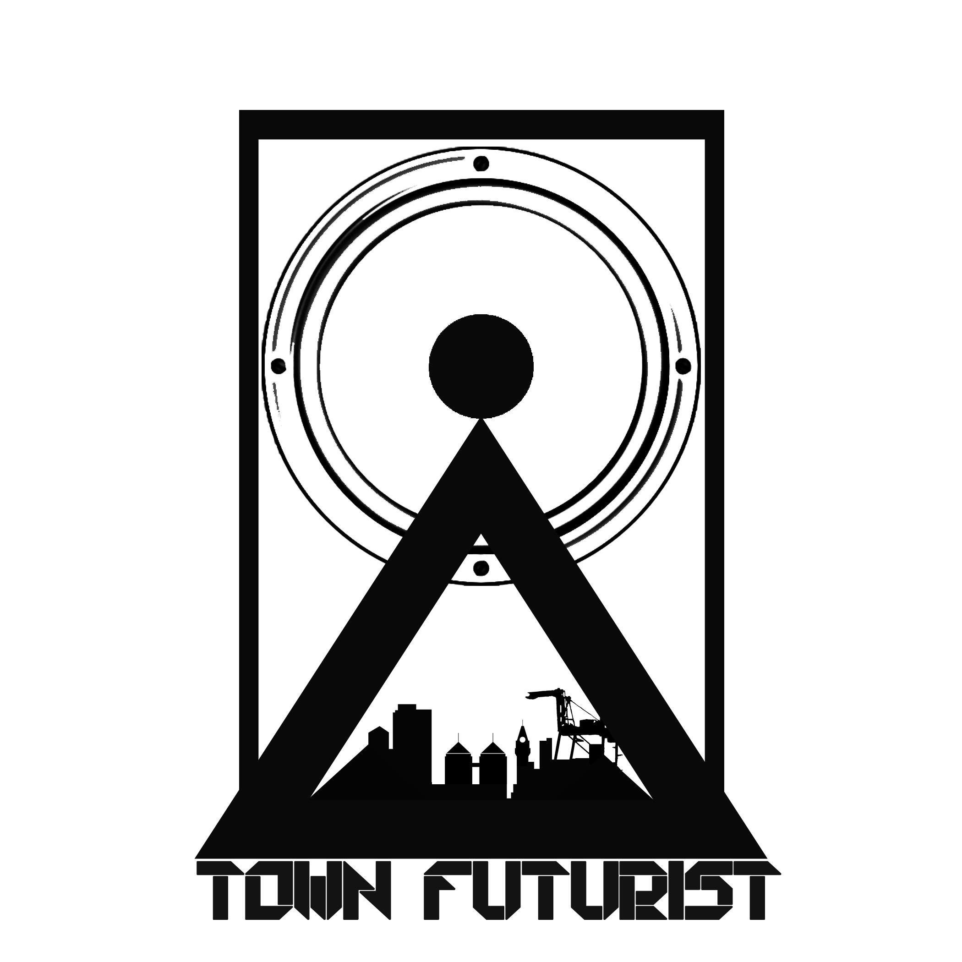 TownFuturist Media Price List
EPK (Electronic Press Kit) or Artist Bio

EPK (Electronic Press Kit) or Artist Bios are a great way to expose Fans, labels and booking agents to your music. This consists of a sit down interview in which you discuss your process as a recording/performing artist as well as your personal story. These interviews can be shot at our studio or a location of your choice. We also like to include B-Roll (other shots of you performing of making music) in the interview if available.

The shoot consists of 2 cameramen and an on director/engineer. We shoot/ book 3hours blocks for the day of the shoot. The first half hour will be set-up and lighting. The last two hours will be shooting your interview and b-roll footage.

Budget:
EPK interview: $500

Contact for available booking days.

Contact:
Korise Jubert
TownFuturist@Gmail.com
510-269-0433
Follow @TownFuturist

